**Fisher Price**

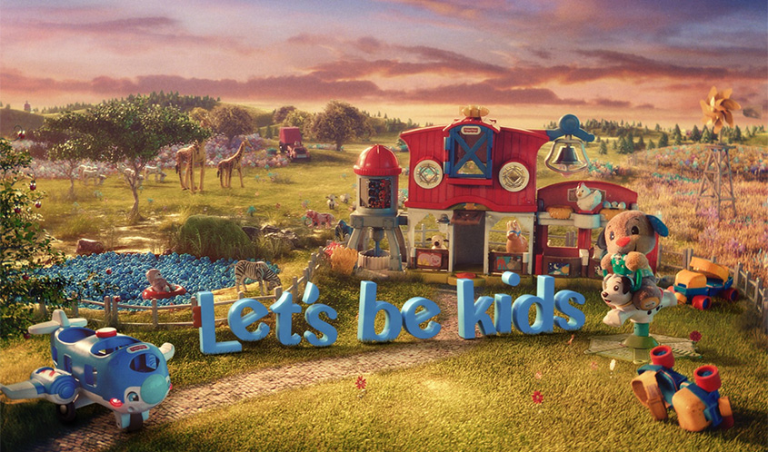

Fisher-Price has created approximately 5,000 different toys since the early 1930s. One of Fisher-Price's best-known lines is Little People toys, which includes people and animal figures along with various play sets such as a house, farm, school, garage and vehicles. The figures, which originally were wooden peg-style characters, are now molded of plastic and have detailed features.

**PRODUCTS**

# ****1.****

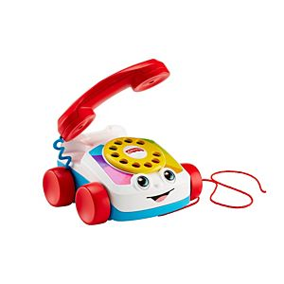

Chatter Telephone®

**Price: $8.99**

**Product Details**

With its friendly face, spinning dial, fun ringing-phone sounds, and eyes that move up and down as you pull it along, the Fisher-Price® Chatter Telephone® helps get your baby chatting—and strolling—like a pro!

**2.**

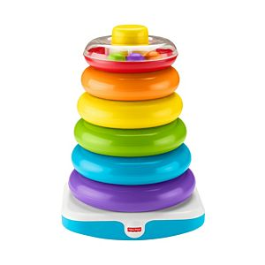

# Fisher-Price® Giant Rock-a-Stack®

# Price: $19.99

**Product Details**

At 15 inches tall, the Fisher-Price® Giant Rock-a-Stack® takes classic stacking play to new heights. Your baby can grasp and shake the six colorful rings, then stack 'em up high on the wibbly-wobbly base. And the littlest ring has swirling beads inside for your tot to shake and explore!

# 3.

# 

# Fisher-Price® Linkimals™ Counting Koala

# Price: $24.99

**Product Details**

# Climbing up a palm tree with their koala friend, baby makes a startling discovery: this tree grows squares, triangles and circles. The Linkimals™ Counting Koala from Fisher-Price is a musical learning friend for babies with exciting lights, songs, and phrases that introduce numbers, counting and shapes. And when Counting Koala meets up with other Linkimals™ friends, they light-up, talk, sing and play together!

# 4.

# 

# Laugh & Learn® Game & Learn Controller

## **Price: $9.99**

**Product Details**

Little gamers control all the hands-on learning of this toy video game controller, which introduces your baby to numbers, colors, shapes, and more!

Your baby can get into the gaming fun with this Laugh & Learn® toy video game controller, which features two 'gaming' modes and lots of hands-on activities! As little gamers move the joystick and press the ABCD and number buttons, they'll hear exciting songs, sounds, and phrases that introduce numbers, shapes, colors, and more!

# 5.

# 

# Fisher-Price® Laugh & Learn® Storybook Rhymes

# Price: $14.99

**Product Details**

# Open up a world of fun and learning for your baby with the Laugh & Learn® Storybook Rhymes from Fisher-Price®. Each page of this musical toy book features colorful illustrations featuring Puppy and Sis. As baby turns the pages, they'll hear childhood favorite songs like 'Pat-a-Cake' or 'Row, Row, Row Your Boat,' as well as learning songs about counting, first words, letters, shapes and more. With its easy-carry handle, little 'readers' can take Storybook Rhymes everywhere they go.

# 6.

# 

# Baby's First Blocks

# Price: $9.97

**Product Details**

Open a bucket of fun for your little one with Baby's First Blocks. These chunky, colorful blocks help introduce colors and shapes as babies sort, stack and drop the blocks through the slots in the bucket lid. Empty the bucket to start the fun over again and again! And with an easy-carry handle, you can take Baby's First Blocks wherever you and your tiny tot go!